

**Lab 02**

**Group :** 07

**Course Code :** CSE209

**Course Title :** Electrical Circuits

**Submitted To**

**Dr. Sarwar Jahan,**

**Associate Professor**

**Department of Computer Science and Engineering**

**Submitted By**

**Name : Sheikh Sarafat Hossain**

**Id No : 2022-3-60-109**

**Section :** 01

**Semester :** Summer 24

**Date of Submission:** 14 July, 2024

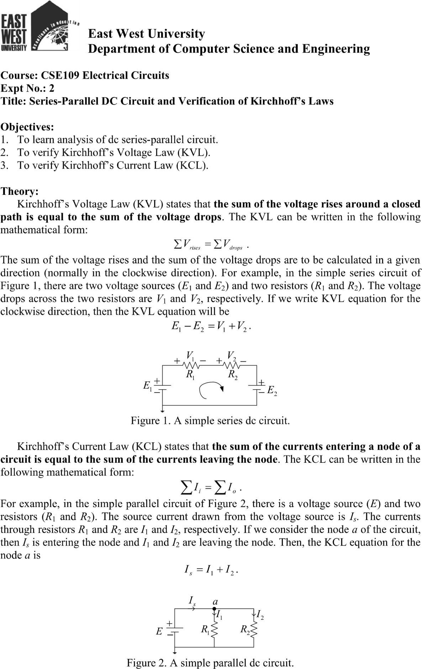

**Pre – Lab Report :**

**1. Theoretical Calculations**

Given:

R₁ = 1000 Ω

R2 = 470 Ω

R3= 1000 Ω

E = 3V

**Finding Total Resistance**

The resistors R2 and R3 are in parallel, so their equivalent resistance (R23) can be calculated as:

**1/R23 = 1/R2 + 1/R3**

**1/R23 = 1/470 +1/1000**

**R23 = (1/470 + 1/1000)-1**

𝑹𝟐𝟑≈ 319 Ω

Now, 𝑹𝟐𝟑is in series with 𝑹𝟏:

𝑹𝒕𝒐𝒕𝒂𝒍 **=** 𝑹𝟏 **+** 𝑹𝟐𝟑

𝑹𝒕𝒐𝒕𝒂𝒍 = 𝟏𝟎𝟎𝟎 + 𝟑𝟏𝟗

𝑹𝒕𝒐𝒕𝒂𝒍≈ 1319 Ω

Finding Total Current ( I1)

𝑬

I1 =

𝑹𝒕𝒐𝒕𝒂𝒍

I1 = 3 / 1319

I1 ≈ 2,27 mA

Voltage across R1 (V1)

V1 = I1 . R1

V1 = 2,27 mA × 1000 Ω

V1  ≈ 2.27 V

Voltage across R23 (V23)

V23 = E – V1

V23 = 3V – 2.27V

V23 ≈ 0.73 V

Current through R2 (I2)

I2 = V23 / R2

I2 = 0.73 / 470

I2 ≈ 1.55 mA Current through R3 (I3)

I3 = v23 / R3

I3 = 0.73 / 1000

I3 ≈ 0.73 mA

1. Verifying KVL and KCL

KVL (Kirchhoff’s Voltage Law)

E =V1 + V23

3V = 2.27 V + 0.73 V

3V = 3V

KVL holds true.

KCL (Kirchhoff’s Current Law)

I1 = I2 +I3

2.27mA = 1.55 mA +0.73mA

2.27 mA = 2.28mA

There is a slight rounding error, but KCL approximately holds true.

**Equipments and Components Needed:**

1. DC power supply
2. DC voltmeter
3. DC ammeter
4. Multimeter
5. Resistor 1000 (two) and 470 (one)
6. Breadboard
7. Connecting wires Lab Procedure:
8. Measure the resistance values of the resistors supplied and record them in Table 1.
9. Construct the circuit of Figure 4. Set the value of E at 3 V. Measure the values of E. V1, V2, V3, I1, I2 and I3, and record them in Table 1.
10. From experimental data, (i) show that V2 = V3 (ii) verify KVL, that is E =V1 + V2, and

(iii) verify KCL, that is I1 = I2 +I3.

Table 1 Experimental Datasheet

|  |  |  |  |  |  |  |  |
| --- | --- | --- | --- | --- | --- | --- | --- |
| Measured  Value of E (V) | Measured  Value of  V1(V) | Measured  Value of  V2(V) | Measured  Value of  V3(V) | Measured  Value of  I1 (mA) | Measured  Value of  I2 (mA) | Measured  Value of  I3 (mA) | Measured  Value of  Resistances  (Ω) |
| 2.8 | 2.09 | 0.66 | 0.66 | 20 | 6 | 14 | R₁ = 0.10  R2 = 0.047  R3= 0.100 |

**Post – Lab Report :**

**1. Theoretical Calculation**

R₁ = 0.10 Ω

R2 = 0.047 Ω

R3= 0.100 Ω

E = 2.8 V

**Finding Total Resistance**

The resistors R2 and R3 are in parallel, so their equivalent resistance (R23) can be calculated as:

1 / R23 = 1/R2 + 1/R3

1 / R23 = 1/ 0.047 + 1/ 0.0100

𝑹𝟐𝟑= ( 1/0 - 1/ 0.047 + 1/ 0.100)

𝑹𝟐𝟑≈ 0.0319 Ω

Now, 𝑹𝟐𝟑is in series with 𝑹𝟏:

𝑹𝒕𝒐𝒕𝒂𝒍 **=** 𝑹𝟏 **+** 𝑹𝟐𝟑

𝑹𝒕𝒐𝒕𝒂𝒍 = 𝟎. 𝟏𝟎 + 𝟎. 𝟎𝟑𝟏𝟗

𝑹𝒕𝒐𝒕𝒂𝒍≈ 0.1319 Ω

Finding Total Current ( I1)

I1 = E / Rtotal

I1 = 28 /0.1319

I1 ≈ 20 mA

Voltage across R1 (V1)

V1 = I1 x R1

V1 = 20 mA × 0.10 Ω

V1  ≈ 2.09V

Voltage across R23 (V23)

V23 = E – V1

V23 = 2.8V – 2.09V

V23 ≈ 0.66 V

V2 = V3 = 0.66

Current through R2 (I2)

I2 =v23/R2

I2 = 0.66/0.047

I2 ≈ 6 mA

Current through R3 (I3)

I3 = v23 / R3

I3 = 0.66 / 0.04

I3 ≈ 14 mA

**2. Verifying KVL and KCL**

KVL (Kirchhoff’s Voltage Law)

E =V1 + V23

2.8V = 2.09 V + 0.66 V

2.8V = 2.75V

There is a slight rounding error , but KVL holds true.

KCL (Kirchhoff’s Current Law)

I1 = I2 +I3

20mA = 6 mA +14 mA

20 mA = 20 mA

KCL approximately holds true.

